[](https://www.stationx.net/)

**Nmap Cheat Sheet**

**Scan Techniques**

Switch

-sS

-sT

-sU

-sA

-sW

-sM

Example

nmap 192.168.1.1 -sS

nmap 192.168.1.1 -sT

nmap 192.168.1.1 -sU

nmap 192.168.1.1 -sA

nmap 192.168.1.1 -sW

nmap 192.168.1.1 -sM

Description

TCP SYN port scan (Default)

TCP connect port scan

(Default without root privilege) UDP port scan

TCP ACK port scan TCP Window port scan TCP Maimon port scan

**Host Discovery**

|  |  |  |
| --- | --- | --- |
| Switch | Example | Description |
| -sL | nmap 192.168.1.1-3 -sL | No Scan. List targets only |
| -sn | nmap 192.168.1.1/24 -sn | Disable port scanning |
| -Pn | nmap 192.168.1.1-5 -Pn | Disable host discovery. Port scan only |
| -PS | nmap 192.168.1.1-5 -PS22-25,80 | TCP SYN discovery on port x. Port 80 by default |
| -PA | nmap 192.168.1.1-5 -PA22-25,80 | TCP ACK discovery on port x. Port 80 by default |
| -PU | nmap 192.168.1.1-5 -PU53 | UDP discovery on port x. Port 40125 by default |
| -PR | nmap 192.168.1.1-1/24 -PR | ARP discovery on local network |
| -n | nmap 192.168.1.1 -n | Never do DNS resolution |

|  |  |  |
| --- | --- | --- |
| **Port Specification** | | |
| Switch | Example | Description |
| -p | nmap 192.168.1.1 -p 21 | Port scan for port x |
| -p | nmap 192.168.1.1 -p 21-100 | Port range |
| -p | nmap 192.168.1.1 -p U:53,T:21-25,80 | Port scan multiple TCP and UDP ports |
| -p- | nmap 192.168.1.1 -p- | Port scan all ports |
| -p | nmap 192.168.1.1 -p http,https | Port scan from service name |
| -F | nmap 192.168.1.1 -F | Fast port scan (100 ports) |
| --top-ports | nmap 192.168.1.1 --top-ports 2000 | Port scan the top x ports |
| -p-65535 | nmap 192.168.1.1 -p-65535 | Leaving off initial port in range makes the scan start at port 1 |
| -p0- | nmap 192.168.1.1 -p0- | Leaving off end port in range makes the scan go through to port 65535 |

|  |  |  |
| --- | --- | --- |
| **Service and Version Detection** | | |
| Switch | Example | Description |
| -sV | nmap 192.168.1.1 -sV | Attempts to determine the version of the service running on port |
| -sV --version-intensity | nmap 192.168.1.1 -sV --version-intensity 8 Intensity level 0 to 9. Higher number increases possibility of correctness | |
| -sV --version-light | nmap 192.168.1.1 -sV --version-li | ght Enable light mode. Lower possibility of correctness. Faster |
| -sV --version-all | nmap 192.168.1.1 -sV --version-a | ll Enable intensity level 9. Higher possibility of correctness. Slower |
| -A | nmap 192.168.1.1 -A | Enables OS detection, version detection, script scanning, and traceroute |

[](https://www.stationx.net/)

**OS Detection**

SwitchExample

-Onmap 192.168.1.1 -O

-O --osscan-limitnmap 192.168.1.1 -O --osscan-limit

-O --osscan-guessnmap 192.168.1.1 -O --osscan-guess

-O --max-os-triesnmap 192.168.1.1 -O --max-os-tries 1

-Anmap 192.168.1.1 -A

Description

Remote OS detection using TCP/IP stack fingerprinting

If at least one open and one closed TCP port are not found it will not try OS detection against host

Makes Nmap guess more aggressively

Set the maximum number x of OS detection tries against a target Enables OS detection, version detection, script scanning, and traceroute

|  |  |  |
| --- | --- | --- |
| **Timing and Performance**  Switch Example Description  -T0 nmap 192.168.1.1 -T0 Paranoid (0) Intrusion Detection System evasion  -T1 nmap 192.168.1.1 -T1 Sneaky (1) Intrusion Detection System evasion  -T2 nmap 192.168.1.1 -T2 Polite (2) slows down the scan to use less bandwidth and use less target machine resources  -T3 nmap 192.168.1.1 -T3 Normal (3) which is default speed  -T4 nmap 192.168.1.1 -T4 Aggressive (4) speeds scans; assumes you are on a reasonably fast and reliable network  -T5 nmap 192.168.1.1 -T5 Insane (5) speeds scan; assumes you are on an extraordinarily fast network | | |
| Switch | Example input | Description |
| --host-timeout <time> | 1s; 4m; 2h | Give up on target after this long |
| --min-rtt-timeout/max-rtt-timeout/initial-rtt-timeout <time> | 1s; 4m; 2h | Specifies probe round trip time |
| --min-hostgroup/max-hostgroup <size> | 50; 1024 | Parallel host scan group sizes |
| --min-parallelism/max-parallelism <numprobes> | 10; 1 | Probe parallelization |
| --scan-delay/--max-scan-delay <time> | 20ms; 2s; 4m; 5h | Adjust delay between probes |
| --max-retries <tries> | 3 | Specify the maximum number of port scan probe retransmissions |
| --min-rate <number> | 100 | Send packets no slower than <number> per secon[d](https://www.stationx.net/) |
| --max-rate <number> | 100 | Send packets no faster than <number> per second |

|  |  |  |  |
| --- | --- | --- | --- |
| **NSE Scripts** | | |  |
| Switch | Example | Description |  |
| -sC | nmap 192.168.1.1 -sC | Scan with default NSE scripts. Considered useful for discovery and safe |  |
| --script default | nmap 192.168.1.1 --script default | Scan with default NSE scripts. Considered useful for discovery and safe |  |
| --script | nmap 192.168.1.1 --script=banner | Scan with a single script. Example banner |  |
| --script | nmap 192.168.1.1 --script=http* | Scan with a wildcard. Example http |  |
| --script | nmap 192.168.1.1 --script=http,banner | Scan with two scripts. Example http and banner |  |
| --script | nmap 192.168.1.1 --script "not intrusive" | Scan default, but remove intrusive scripts |  |
| --script-args nmap --script snmp-sysdescr --script-args snmpcommunity=admin 192.168.1.1 NSE script with arguments  **Useful NSE Script Examples**  Command Description  nmap -Pn --script=http-sitemap-generator scanme.nmap.org http site map generator  nmap -n -Pn -p 80 --open -sV -vvv --script banner,http-title -iR 1000 Fast search for random web servers  nmap -Pn --script=dns-brute domain.com Brute forces DNS hostnames guessing subdomains  nmap -n -Pn -vv -O -sV --script smb-enum*,smb-ls,smb-mbenum,smb-os-discovery,smb-s*,smb-vuln*,smbv2* -vv 192.168.1.1 Safe SMB scripts to run nmap --script whois* domain.com Whois query  nmap -p80 --script http-unsafe-output-escaping scanme.nmap.org Detect cross site scripting vulnerabilities. nmap -p80 --script http-sql-injection scanme.nmap.org Check for SQL injections | | |  |



## Firewall / IDS Evasion and Spoofing

Switch Example Description

-f nmap 192.168.1.1 -f Requested scan (including ping scans) use tiny fragmented IP packets. Harder for packet filters

--mtu nmap 192.168.1.1 --mtu 32 Set your own offset size

-D nmap -D 192.168.1.101,192.168.1.102,192.168.1.103,192.168.1.23 192.168.1.1 Send scans from spoofed IPs

-D nmap -D decoy-ip1,decoy-ip2,your-own-ip,decoy-ip3,decoy-ip4 remote-host-ip Above example explained

-S nmap -S [www.microsoft.com](http://www.microsoft.com/) [www.facebook.com](http://www.facebook.com/) Scan Facebook from Microsoft (-e eth0 -Pn may be required)

-g nmap -g 53 192.168.1.1 Use given source port number

--proxies nmap --proxies http://192.168.1.1:8080, http://192.168.1.2:8080 192.168.1.1 Relay connections through HTTP/SOCKS4 proxies

--data-length nmap --data-length 200 192.168.1.1 Appends random data to sent packets

## Example IDS Evasion command

nmap -f -t 0 -n -Pn --data-length 200 -D 192.168.1.101,192.168.1.102,192.168.1.103,192.168.1.23 192.168.1.1

|  |  |  |
| --- | --- | --- |
|  | | **Output** |
| Switch | Example | Description |
| -oN | nmap 192.168.1.1 -oN normal.file | Normal output to the file normal.file |
| -oX | nmap 192.168.1.1 -oX xml.file | XML output to the file xml.file |
| -oG | nmap 192.168.1.1 -oG grep.file | Grepable output to the file grep.file |
| -oA | nmap 192.168.1.1 -oA results | Output in the three major formats at once |
| -oG - | nmap 192.168.1.1 -oG - | Grepable output to screen. -oN -, -oX - also usable |
| --append-output | nmap 192.168.1.1 -oN file.file --append-output | Append a scan to a previous scan file |
| -v | nmap 192.168.1.1 -v | Increase the verbosity level (use -vv or more for greater effect) |
| -d | nmap 192.168.1.1 -d | Increase debugging level (use -dd or more for greater effect) |
| --reason | nmap 192.168.1.1 --reason | Display the reason a port is in a particular state, same output as -vv |
| --open | nmap 192.168.1.1 --open | Only show open (or possibly open) ports |
| --packet-trace | nmap 192.168.1.1 -T4 --packet-trace | Show all packets sent and received |
| --iflist | nmap --iflist | Shows the host interfaces and routes |
| --resume | nmap --resume results.file | Resume a scan |
| **Helpful Nmap Output examples**  Command Description  nmap -p80 -sV -oG - --open 192.168.1.1/24 | grep open Scan for web servers and grep to show which IPs are running web servers nmap -iR 10 -n -oX out.xml | grep "Nmap" | cut -d " " -f5 > live-hosts.txt Generate a list of the IPs of live hosts  nmap -iR 10 -n -oX out2.xml | grep "Nmap" | cut -d " " -f5 >> live-hosts.txt Append IP to the list of live hosts  ndiff scanl.xml scan2.xml Compare output from nmap using the ndiff  xsltproc nmap.xml -o nmap.html Convert nmap xml files to html files  grep " open " results.nmap | sed -r 's/ +/ /g' | sort | uniq -c | sort -rn | less Reverse sorted list of how often ports turn up | | |

[](https://www.stationx.net/)

|  |  |  |  |
| --- | --- | --- | --- |
| **Miscellaneous Options** | | |  |
| Switch | Example | Description |  |
| -6  -h | nmap -6 2607:f0d0:1002:51::4  nmap -h | Enable IPv6 scanning nmap help screen |  |

|  |  |
| --- | --- |
| **Other Useful Nmap Commands** | |
| Command | Description |
| nmap -iR 10 -PS22-25,80,113,1050,35000 -v -sn | Discovery only on ports x, no port scan |
| nmap 192.168.1.1-1/24 -PR -sn -vv | Arp discovery only on local network, no port scan |
| nmap -iR 10 -sn -traceroute | Traceroute to random targets, no port scan |
| nmap 192.168.1.1-50 -sL --dns-server 192.168.1.1 | Query the Internal DNS for hosts, list targets only |

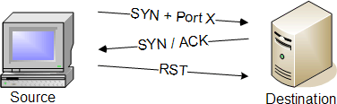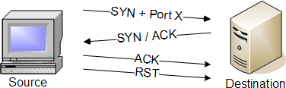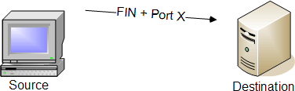

**Identifying Open Ports with Nmap**

**TCP SYN SCAN (-sS)**

**TCP connect() SCAN (-sT)**

**TCP FIN SCAN (-sF)**

**TCP FIN SCAN (-sF)**

**TCP XMAS TREE SCAN (-sX)**

**TCP PING SCAN (-sP)**

**VERSION DETECTION SCAN (-sV)**

**IP PROTOCOL SCAN (-sO)**

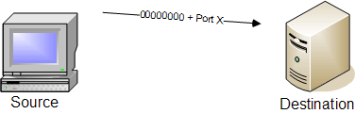

**TCP NULL SCAN (-sN)**

Version scan identifies open pots with a TCP SYN scan…

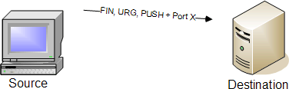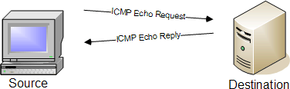

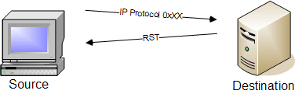…and then queries the port with a customized signature.

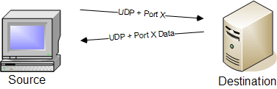

**UDP SCAN (-sU)**

**TCP WINDOW SCAN (-sW)**

**TCP ACK SCAN (-sA)**

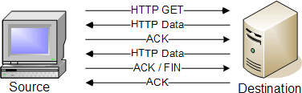 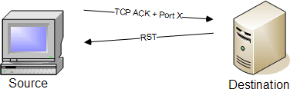 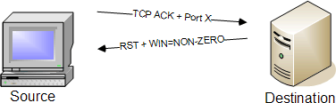

# IDLESCAN (-sI <zombie host: [probeport]>)

Step 1: Nmap sends a SYN/ACK to the zombie workstation to induce a RST in return. This RST frame contains the initial IPID that nmap will remember for later.

Step 2: Nmap sends a SYN frame to the destination address, but nmap spoofs the IP address to make it seem as if the SYN frame was sent from the zombie workstation.

Step 3: Nmap repeats the original SYN/ACK probe of the zombie station. If the IPID has incremented, then the port that was spoofed in the original SYN frame is open on the destination device.

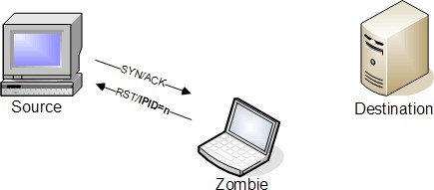 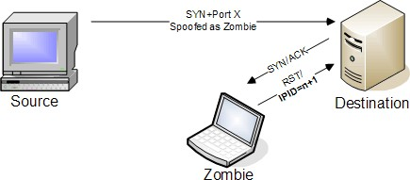 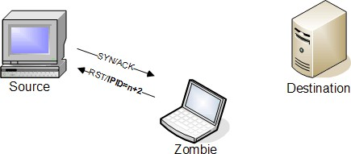

# FTP BOUNCE ATTACK (-b <ftp_relay_host>)

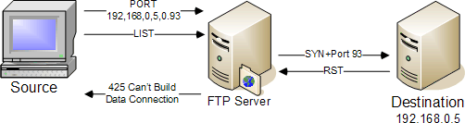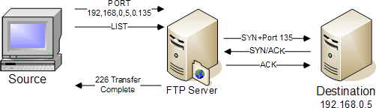

A closed port will result with the FTP server informing the source station that the FTP server can’t build the connection.

An open port completes the transfer over the specified connection.

NOTE: Be aware that the FTP bounce scan is not workable since most FTP Servers will not perform what is needed for the scan. This is more for information purposes.

[www.stationx.net/nmap-cheat-sheet/](http://www.stationx.net/nmap-cheat-sheet/)

[**6**](http://www.stationx.net/nmap-cheat-sheet/)